***ANUDIP FOUNDATION***

A Project Report on

**“STUDENTS ATTENDANCE MANANGEMENT SYSTEM USING FACE DECETION”**

By

Batch: ANP-D0453

Student ID: AF0477052

Student ID: AF0477040

Name: Shweta Basavaraj Kore.

Name: Shweta Jagdish Chavan.

**Under the Guidance of**

Mrs. Rajshri Chandrabhan Thete.

“STUDENTS ATTENDANCE MANANGEMENT SYSTEM USING FACE DETECTION”

**Entities:**

* Student
* Admin
* Attendance
* Teacher
* Registration

**VARIOUS ENTITIES:**

1. **Student**

* **StudentID** (Primary Key)
* Name
* Email
* Section
* Roll_Number
* Class

1. **AttendanceReports**

* **ReportID** (Primary Key)
* StudentID(Foreign Key)
* Attendance_Date
* Status

1. **Attendance**

* Attendance_ID (Primary key)
* StudentId(Foreign Key)
* Attendance_Date
* Status
* Remarks

**4.Teacher**

* Teacher_ID (Primary Key)
* Name
* Email

**5. Classes**

* Class_Name
* Class_ID (Primary Key)

**6. Subjects**

* Subject_ID(Primary Key)
* SubjectName

**ENTITY RELATIONSHIP DIAGRAM – STUDENT ATTENDANCE MANAGEMENT SYSTEM USING FACE DETECTION.**

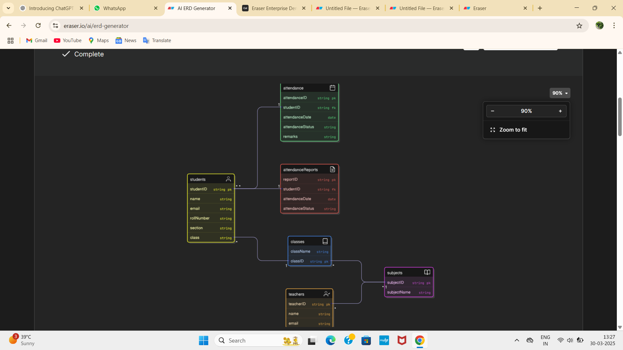

**CONCLUSION:**

InConclusion, A Student Management System using Face Detection offers a modern, efficient and secure approach to attendance tracking and student identification, ultimately Streamlining administrative tasks and improving accuracy while minimizing human error.

**DATABASE CREATION QUERY:**

mysql> CREATE DATABASE IF NOT EXISTS attendance_manage;

Query OK, 1 row affected (0.00 sec)

mysql> USE attendance_manage;

Database changed

mysql> CREATE TABLE IF NOT EXISTS AttendanceReport (

-> reportID bigint NOT NULL AUTO_INCREMENT,

-> attendanceDate date,

-> attendanceStatus varchar(255),

-> student_id bigint,

-> PRIMARY KEY (reportID)

-> );

Query OK, 0 rows affected (0.01 sec)

mysql> CREATE TABLE IF NOT EXISTS ClassEntity (

-> classID bigint NOT NULL AUTO_INCREMENT,

-> className varchar(255),

-> PRIMARY KEY (classID)

-> );

Query OK, 0 rows affected (0.01 sec)

mysql> CREATE TABLE IF NOT EXISTS Student (

-> studentID bigint NOT NULL AUTO_INCREMENT,

-> email varchar(255),

-> name varchar(255),

-> rollNumber varchar(255),

-> section varchar(255),

-> class_id bigint,

-> PRIMARY KEY (studentID)

-> );

Query OK, 0 rows affected (0.01 sec)

mysql> CREATE TABLE IF NOT EXISTS Subject (

-> subjectID bigint NOT NULL AUTO_INCREMENT,

-> subjectName varchar(255),

-> PRIMARY KEY (subjectID)

-> );

Query OK, 0 rows affected (0.01 sec)

mysql> CREATE TABLE IF NOT EXISTS Teacher (

-> teacherID bigint NOT NULL AUTO_INCREMENT,

-> email varchar(255),

-> name varchar(255),

-> PRIMARY KEY (teacherID)

-> );

Query OK, 0 rows affected (0.01 sec)